# **The Essential Guide to Temperature Monitoring Across Industries**

As the advanced technologies are being used in every industry, temperature monitoring systems are becoming popular at the global level. These systems are completely ready to work with advanced technologies.

According to a [report by Researchnester](https://www.researchnester.com/reports/temperature-monitoring-system-market/404), the market size of temperature monitoring systems was valued at USD 3.17 Billion in 2023. This market value is estimated to increase to USD 6.52 Billion by 2036.

Here it is

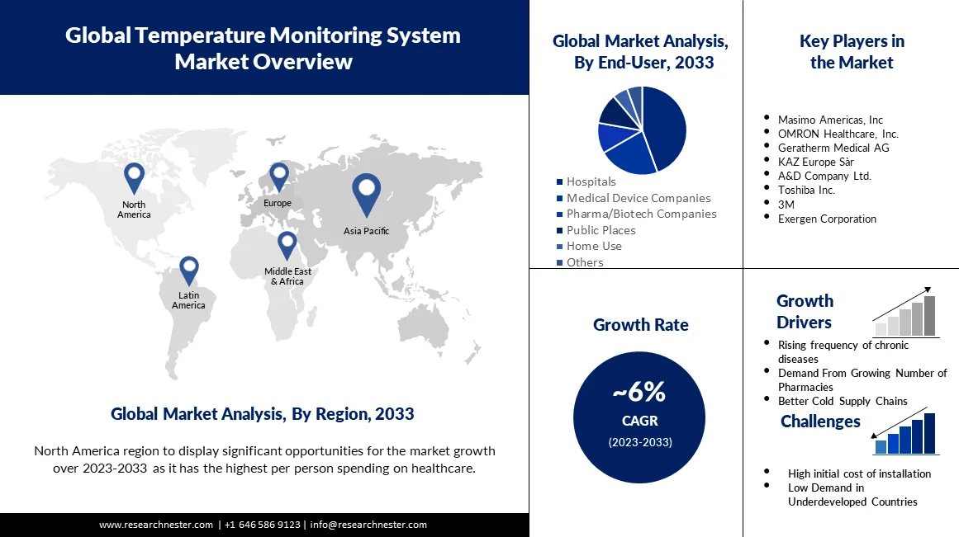

(Image Source: Researchnester)

This expansion is being driven by many factors such as advancement in wireless monitoring, demand for environmental control within the premises, and integration of AI technology. Industries such as healthcare, manufacturing, food and beverages, automotive are using these technologies extensively to ensure the safety, efficiency and regulation compliances.

And all this has been possible because of IoT technology. Today, in these industries, devices equipped with this technology can connect to local WiFi and record equipment and other data which can then be accessed remotely.​

In this blog today we will discuss what is the role of temperature monitoring systems in different industries and how many types are there. Overall we will deeply analyze each factor and see what are the advantages of these systems in which industries, what are their limitations and what are their applications.

All in all this is going to be a power packed blog which will give you an opportunity to know temperature monitoring systems closely.

## **The Role of Temperature Monitoring Across Industries**

### **Healthcare Industry**



When it comes to the healthcare sector, temperature monitoring is a vital component of the medical refrigeration system. Medicines, vaccines and blood samples need to be kept within an approved temperature range to maintain their safety and efficacy.

Regular temperature monitoring reduces the chances of products spoiling to a minimum or to none. By doing this, healthcare providers can save money in the long run.

The World Health Organization has highlighted that if healthcare products such as vaccines are not kept at the correct temperature, the chances of them spoiling increase, which in turn affects the public health efforts of governments.

**Cold Chain Management:** Vaccine storage and transport must strictly adhere to set temperatures. This temperature range is often between 2°C and 8°C. According to the CDC, improper vaccine storage affects 37% of vaccines globally, resulting in losses worth billions.

**Hospital Use:** In hospitals, temperature monitoring is most used in blood banks, operating rooms, and incubators. Here, real-time monitoring systems ensure compliance with strict guidelines set by the U.S. FDA.

### **Food and Beverage Industry**

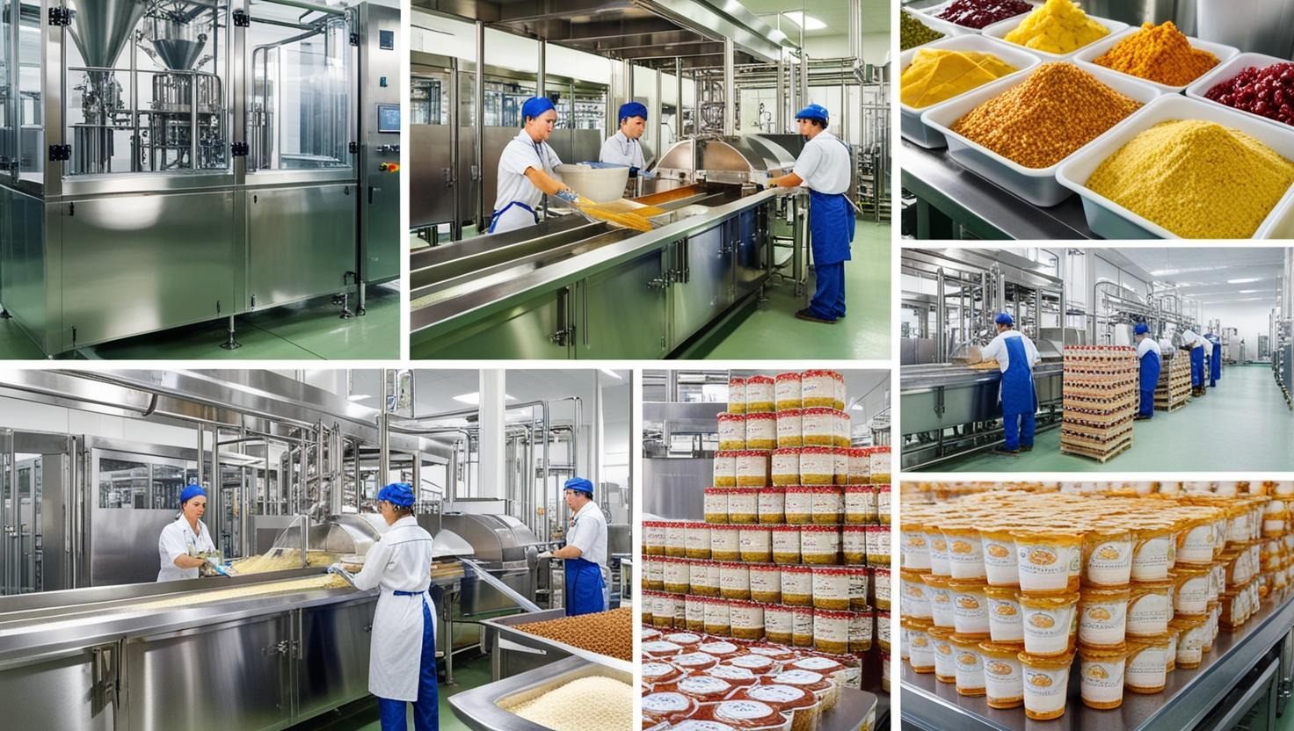

In the food and beverage industry, temperature monitoring is not just a good idea but a necessity of the day. A small mistake in food storage can spoil the food and promote bacterial growth, which puts consumers at risk of health hazards. If consumers suffer losses, it will directly affect the reputation of your food business.

According to an estimate by the FDA, due to lack of proper monitoring of the cold chain, approximately 48 million Americans suffer from foodborne illnesses.

To avoid all these issues, food manufacturers have to rely on technology, the most important of which is temperature monitoring systems. These prevent food from spoiling by alerting business owners to fluctuating temperatures all the time.

**Cold Storage:** Maintains optimal temperatures during transportation and storage. Also ensures compliance with regulations like the Hazard Analysis and Critical Control Points (HACCP).

**Food Processing:** Accurate monitoring is strictly required during cooking, cooling and packaging to maintain the nutritional value.

**Real-Time alerts:** Refrigerated trucks have IoT-enabled sensors that provide real-time data and alerts about food. This has reduced food spoilage rates by up to 15%, as seen in Walmart’s cold chain system.

### **Manufacturing Industry**

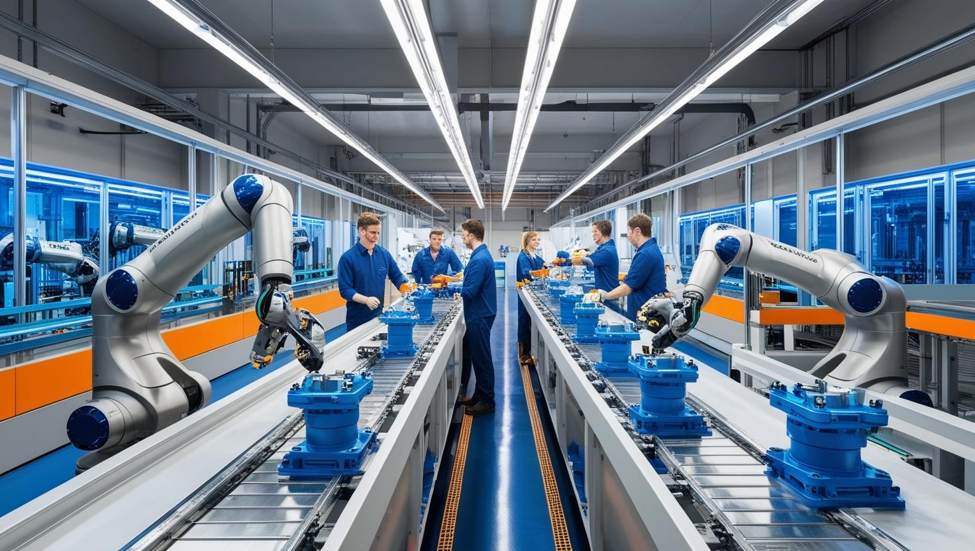

In the manufacturing industry, it is very important to have a proper heating and cooling system. Because the efficiency of workers in the manufacturing line is greatly affected by the optimal temperature. In such a situation, temperature monitoring systems are very important to maintain the environment of the premises.

**Aerospace and Automotive:** Metals and plastics are used the most in the aerospace and automotive industry. They perform different functions based on their heating and cooling. Boeing uses a high tech temperature monitoring system so that composite materials can be easily fixed. This allows the parts of the airplane to be cooled or heated as needed.

**Chemical Production:** Chemicals also need a set temperature to give best performance. And the chemical processes which are there to make the products safely often need precise temperature control. Even a change of 1-2°C can be fatal.

**Machine Maintenance:** Many times the equipment installed in the machinery gets very hot during working. In this case, it breaks down without any warning, which is very expensive to repair. With the help of predictive temperature tracking, the industries can get the information in advance about the possibility of machinery breakdown. This can save a lot of their expenses.

### **Data Centres**

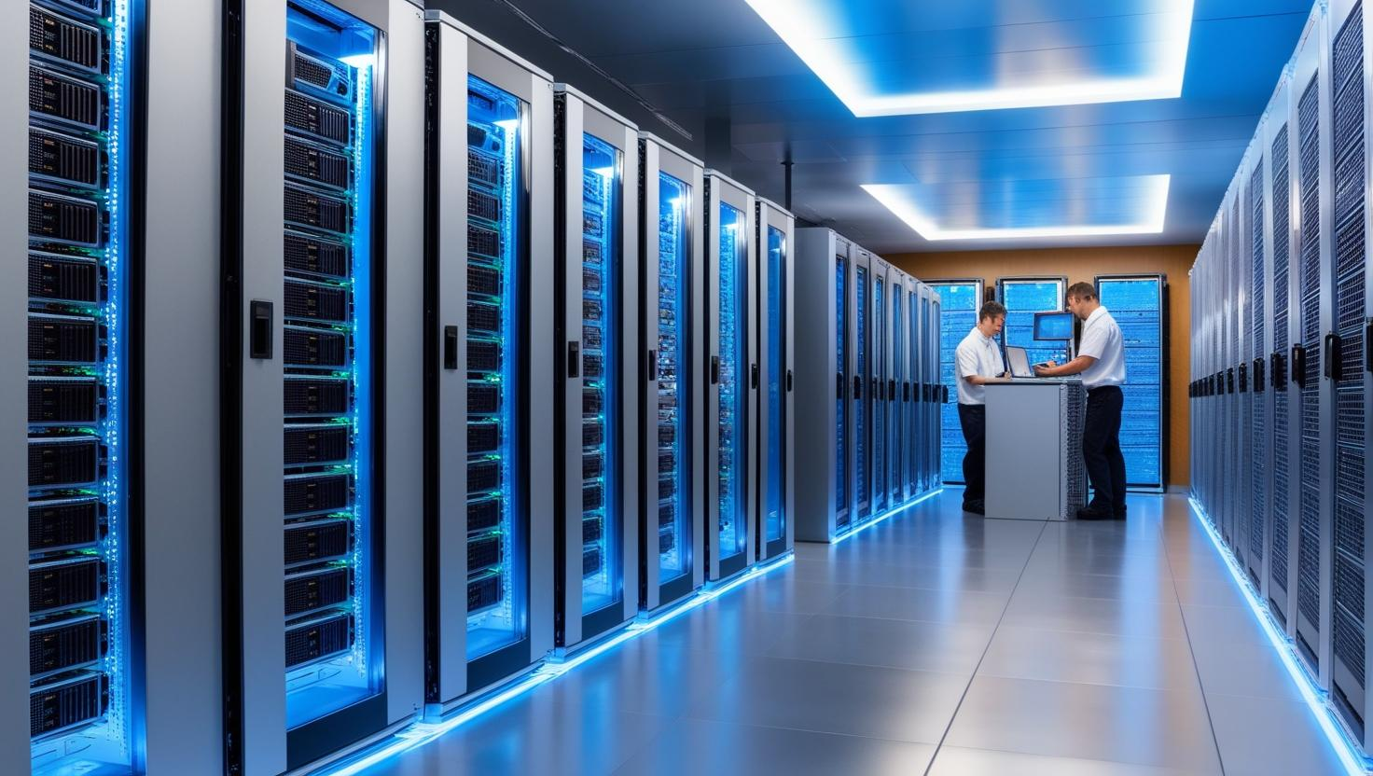

According to one report, the average cost of unplanned failures in data centers is $8,850 per minute. And one of the biggest reasons for these failures is overheating.

Data centers generate excessive heat, especially in the IT industry which works 24*7, there is a high chance of failure of data center equipment. Here temperature monitoring is very important to prevent equipment failure. And if any equipment failure happens once, then businesses can lead to costly repairs, data loss and corruption.

IoT devices are a great help here, they provide:

**Real-Time Monitoring:** IoT-based temperature sensors alert whenever the temperature on servers exceeds the threshold limit, which can prevent equipment from getting damaged.

**Energy Efficiency:** Using real-time temperature data to improve cooling systems lowers the cost of energy use. Google, for example, uses AI-driven tracking to cut the amount of energy it needs to cool its data centers by 40%.

### **Agriculture Industry**



Smart soil management is the key to smart farming as it helps farmers produce the most food possible. Sensors that measure the temperature and humidity of the soil are the best tools to reach this goal. These sensors get accurate information about the conditions of the land, which helps farmers change how they farm in a smart and effective way. Farmers can get the most out of irrigation, avoid waste, improve crop health, and boost yields by using these tools in their work.

**Greenhouse Management:** Sensors monitor the environmental temperature and soil humidity in real-time and optimize these factors according to the requirements. This improves the growth of plants. According to a research report, smart greenhouses can increase crop yield by up to 25% as compared to traditional methods.

**Cold Storage for Crops:** With the help of IoT devices, crop quality can be maintained by properly controlling the temperature during storage. The Food and Agriculture Organization (FAO) estimates that 14% of the world's food is lost post-harvest, with inadequate storage being a key factor.

**Livestock Monitoring:** Preserving steady temperatures is important for keeping animals healthy and productive, and it also cuts down on losses caused by heat stress.

## **Types of Temperature Monitoring Systems**

With the advancements in technology, temperature monitoring systems have also evolved. New systems have come into the market to meet the needs of businesses. These are:

### **Manual Temperature Monitoring Systems**

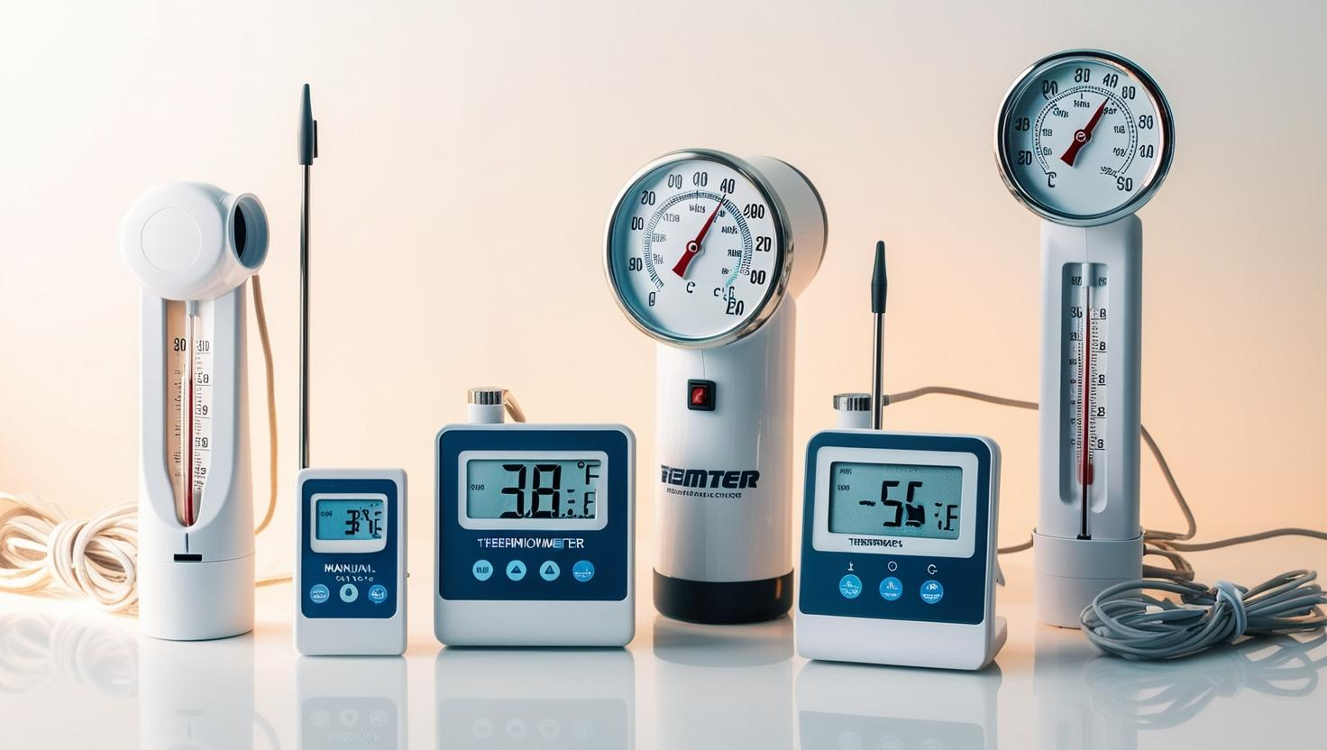

Manual temperature monitoring is a traditional form of monitoring that uses basic devices. These include mercury thermometers, alcohol thermometers, or bimetallic strips to measure and record the temperature.

#### **How Does the Manual Temperature Monitoring System Work?**

The user must physically record the temperature on the device. For example, a bimetallic thermometer measures temperature by using two metals. These metals expand at different rates and give a simple analog reading.

#### **Advantages**

***Cost-Effective:*** These systems are quite cost effective. There is not much initial investment in it, so startups with low investment can use it.

***Low Maintenance:*** There is not much maintenance cost for these systems.

***No Power Dependency:*** These temperature monitoring devices can work without electricity or batteries.

#### **Limitations**

***Labor-Intensive:*** It requires recording readings manually, which may require hiring extra labour.

***Inaccuracy Risks:*** Although these systems do not make any mistake in showing temperature, there is a high chance of human error during manual reading.

***No Real-Time Monitoring:*** It does not alert if there is any rapid change in temperature, due to which real time temperature monitoring cannot be done.

#### **Applications**

These systems are mostly used in small scale applications. Like household freezers or simple laboratory setups where there is not much budget or there is no need for advanced technology.

### **Digital Temperature Monitoring Systems**

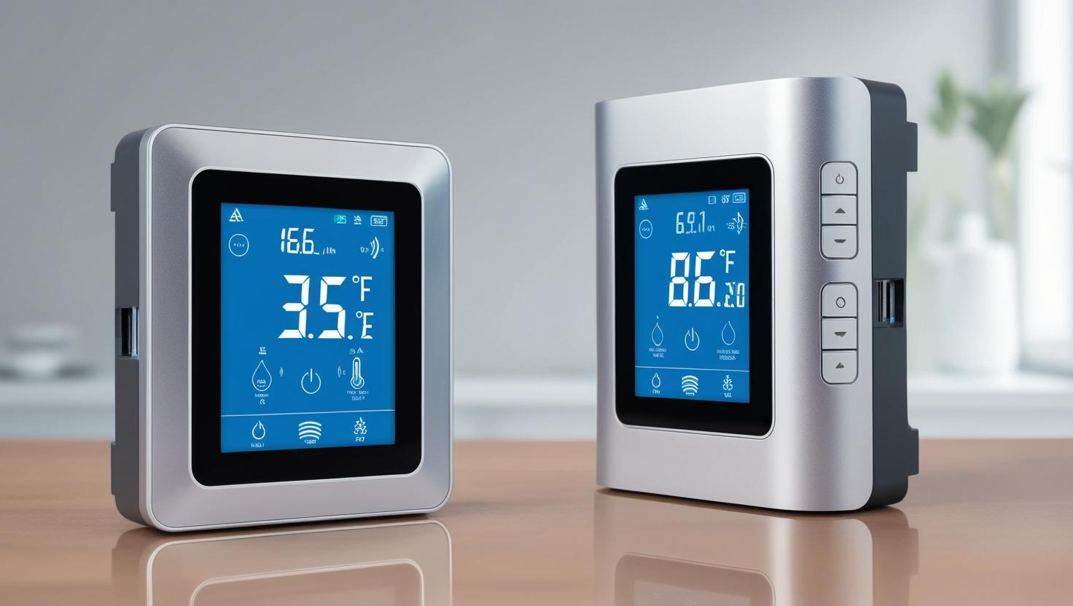

Digital temperature monitoring systems are an upgraded version of manual systems. As compared to manual systems, it provides better accuracy, is easier to use, and includes some better features such as data logging.

#### **How Does the Digital Temperature Monitoring System Work?**

Digital temperature monitoring systems have digital thermometers that have sensors such as thermistors or thermocouples to measure the temperature. And they measure the temperature and display their readings on LED or LCD screens. Some advanced models are also there that store data as well as have downloadable logs.

#### **Advantages**

***Higher Accuracy:*** These systems are quite accurate. They can measure temperature with a precision of up to 0.1°C.

***Ease of Use:*** Its interface is simple, so anyone can easily use it. It also has digital readouts which makes readings easy to read and note.

***Data Logging:*** They can store temperature, which makes it easy to analyze the temperature.

#### **Limitations**

***Limited Connectivity:***Real-time remote monitoring is not possible unless they are paired with additional systems.

***Power Dependency and Higher Costs:*** To use them, external power sources or batteries are required. This causes additional expense and their cost increases a bit.

#### **Applications**

They are mostly used in laboratories, food storage facilities and industrial processes. Especially where accuracy and data retention is of higher importance

### **IoT-Based Temperature Monitoring Systems**

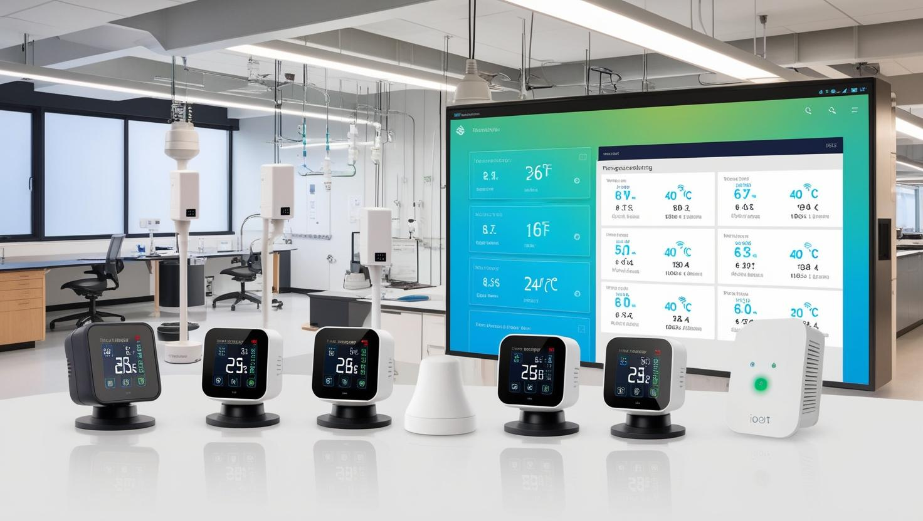

IoT-based systems are among the most advanced temperature monitoring systems. These systems use interconnected sensors and devices to provide real-time data and actionable insights.

#### **How Does IoT-Based Temperature Monitoring Systems work?**

IoT-enabled sensors such as thermocouples or RTDs are installed to measure temperature in critical areas of a premise. The specialty of these sensors is that they can transfer data directly to cloud platforms without any complex systems. This data is later analyzed and displayed on the dashboard or mobile apps.

#### **Advantages**

***Real-Time Monitoring:*** These systems are capable of real-time monitoring of any equipment. These provide instant updates and alerts so that the required action can be taken immediately.

***Remote Access:***With the help of these systems, data can also be generated remotely with the help of the internet.

***Predictive Maintenance:*** These systems have AI technology that can predict the time of failure of any equipment. It is especially beneficial in the manufacturing industry.

***Scalability and Integration:*** They are scalable for large-scale industrial applications. They can also be easily integrated with other systems such as HVAC, supply chain management, and security systems.

#### **Limitations**

***High Initial Costs:*** The initial costs for installing these systems are quite high. It may be a little difficult for small scale and startups to afford it.

***Connectivity Dependency:*** A reliable internet connection is required to use these systems.

***Complexity:*** Setting up these systems is not that easy. Technical expertise is required for this. Apart from this, their maintenance is also quite costly.

#### **Applications**

***Healthcare:*** IoT based monitoring systems are used a lot in the healthcare industry. These systems are quite beneficial when vaccines are transferred from one place to another or proper storage is required.

***Food and Beverage:*** In the food industry, when products are transported, some products are kept at a set temperature. In this case, IoT based monitoring systems are quite helpful in maintaining those temperatures.

***Data Centres:*** Data centres require cooling systems to prevent overheating. These IoT based monitoring systems are needed to maintain the temperature in those systems.

## **What’s Next?**

As technology becomes more advanced, we will see more potential innovations in these systems. They are changing the way businesses operate, reducing risk and opening up new opportunities.

Whether it's manufacturing, storing or transporting life-saving vaccines in the healthcare industry or optimizing the environment and processes in manufacturing plants, these systems play an important role.

If you too want to implement or upgrade a temperature monitoring system in your businesses, then this is the right time. Do not be confused at all, because this is not just an investment, it is a commitment to quality and reliability.

Good Luck..!!