**Stem Cell Supplements: The Key to Unlocking Enhanced Vitality and Longevity**

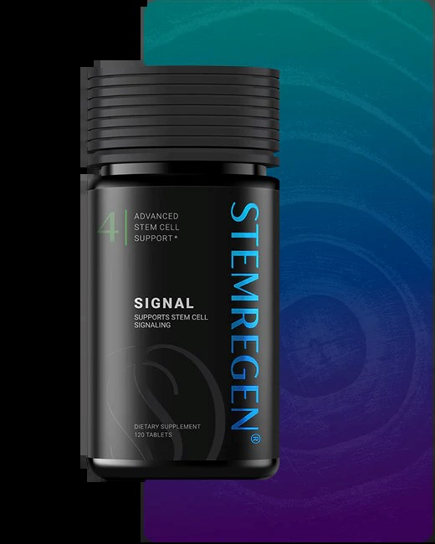

**Introduction**

In recent years, stem cell supplements have gained immense popularity in the world of health and wellness. With their potential to enhance vitality, slow aging, and improve overall well-being, these supplements are capturing the attention of researchers and consumers alike. But what exactly are stem cell pills, and how can they contribute to a healthier, longer life?

In this blog, we will explore the science behind stem cell supplements, their benefits, and how incorporating them into your routine might be the next big step toward optimizing your health and longevity.

**Understanding Stem Cell Supplements**

**What Are Stem Cells and How Do They Work?**

Stem cells are the building blocks of life, with the unique ability to develop into various types of cells in the body. They play a critical role in repair, regeneration, and overall cellular health. However, as we age, our body’s natural production of stem cells declines, leading to slower healing, reduced energy levels, and visible signs of aging.

This is where [**stem cell supplements**](https://anti-agingtoday.com/stem-cells/) come into play. These products are designed to stimulate the body's natural production of stem cells, helping to rejuvenate and repair damaged tissues. Ingredients like plant extracts, peptides, and essential nutrients work synergistically to support the body’s natural regenerative processes.

**Why Choose Stem Cell Pills Over Other Supplements?**

Unlike traditional vitamins and minerals, stem cell pills target the root cause of aging and cellular decline. By promoting stem cell production, these supplements address aging at a deeper level, offering benefits that go beyond surface-level health improvements. Moreover, their ability to enhance cellular repair can lead to improved vitality, increased energy, and a more youthful appearance.

**Benefits of Stem Cell Supplements**

**Enhanced Cellular Regeneration**

One of the most remarkable benefits of stem cell supplements is their ability to support cellular regeneration. By replenishing stem cells in the body, these supplements help repair tissues and combat the wear and tear associated with aging.

For example, individuals who use [**stem cell pills**](https://anti-agingtoday.com/stem-cells/) often report faster recovery from injuries, improved skin elasticity, and reduced inflammation—all of which contribute to a more vibrant and active lifestyle.

**Slowing Down the Aging Process**

Aging is inevitable, but its effects can be managed. Stem cell supplements have shown promise in slowing down the visible and internal signs of aging. They help maintain youthful skin, improve joint health, and boost overall energy levels by addressing the decline in stem cell activity associated with aging.

According to Anti-Aging Today, users of these supplements have experienced noticeable improvements in skin texture, reduced wrinkles, and enhanced physical endurance—all signs of a rejuvenated body.

**Supporting Immune System Health**

The immune system relies heavily on healthy cells to function optimally. Stem cell supplements not only enhance cell regeneration but also strengthen the immune system, making the body more resilient against illnesses. By improving cellular health, these supplements can help the body fend off infections and recover faster from sickness.

**Choosing the Right Stem Cell Supplements**

**Key Ingredients to Look For**

Not all stem cell pills are created equal. When selecting a supplement, it’s essential to look for products that contain high-quality, research-backed ingredients such as:

* **Plant-Based Extracts**: Support the natural release of stem cells from bone marrow.
* **Peptides**: Enhance cellular communication and regeneration.
* **Antioxidants**: Protect cells from oxidative stress and damage.

Products recommended by trusted brands like Anti-Aging Today are often formulated with these ingredients to ensure maximum efficacy.

**Are Stem Cell Supplements Safe?**

Safety is a critical consideration when incorporating any new supplement into your routine. Most high-quality [**stem cell**](https://anti-agingtoday.com/stem-cells/) supplements are derived from natural ingredients and undergo rigorous testing to ensure safety and effectiveness. However, it is always advisable to consult with a healthcare professional before starting any new supplement, especially for individuals with pre-existing health conditions.

**Real-Life Applications of Stem Cell Supplements**

**Boosting Athletic Performance**

For athletes and fitness enthusiasts, stem cell pills offer a unique advantage by accelerating recovery times and improving physical performance. Enhanced cellular repair allows for better endurance, reduced muscle soreness, and quicker healing from injuries.

**Promoting Skin Health**

From reducing fine lines to improving hydration levels, stem cell supplements are becoming a go-to solution for those seeking youthful, glowing skin. Their ability to boost collagen production and improve skin elasticity makes them a powerful ally in any skincare regimen.

**Improving Cognitive Function**

Research suggests that stem cell supplements may also have a positive impact on brain health. By promoting the regeneration of neurons, these supplements could support improved memory, focus, and overall cognitive function, particularly in older adults.

**Conclusion**

The growing interest in stem cell supplements highlights their potential to revolutionize the way we approach health and aging. By enhancing cellular regeneration, supporting immune function, and slowing down the aging process, these supplements provide a comprehensive solution for those seeking to optimize their vitality and longevity.

If you’re ready to take the next step in your wellness journey, consider exploring high-quality products from trusted brands like [**Anti-Aging Today**](https://anti-agingtoday.com/). Whether you’re looking to enhance your energy levels, improve your skin health, or simply feel more youthful, stem cell pills could be the key to unlocking your full potential.